My Personal Vision

Video Game Designer

Jerry Xing

TAE 5

British Columbia Institute of Technology

19th July 2023

Table of Contents

1.0 My Vision 3

1.1 Introduction 3

1.2 Background 3

2.0 My job 3

2.1 Findings 3

2.2 Results 3

2.3 Facts 4

3.0 My Challenges 4

3.1 Findings 4

3.2 Results 4

3.3 Facts 4

4.0 My Mission 4

4.1 Summary 4

4.2 Conclusion 4

4.3 Recommendations 5

5.0 References 6

1. **My vision**
   1. **Introduction**

This report introduces some challenges and plans for my future Video game designer work.

* 1. **Background**

My vision statement is that I hope to design a thought-provoking game that will truly be loved and even serve as a second life for people, like what “The Witcher III: Wild Hunt” of CD Project Red has achieved.

1. **My job**
   1. **Findings**

I will become a video game designer in a game company in the future. In fact, there are at least four kinds of designers for an extensive program in a big company, including Lead designer, Game mechanics designer, Level designer and Planner. My expected job role is a level designer. The level designer creates a game environment, levels, and missions. I aspire to leave a lasting impression on players through my design quests.

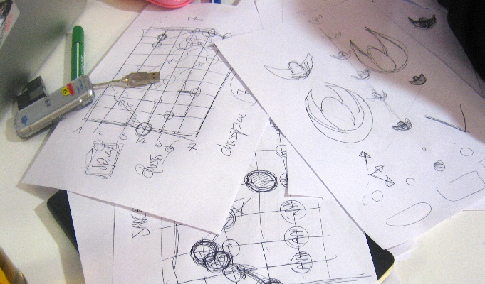

* 1. **Results**

I chose these pictures because the first slide showcases the work environment and some work methods of particular designers. In contrast, the second slide displays a draft illustrating the thought process of a game designer.

These pictures show that a game designer is akin to a graphic designer, industrial designer, or architect that needs the ability to create; they may work alone or as part of a team. They have the flexibility to create various types of games, ranging from card games to social games and video games.

* 1. **Facts**

I chose this job because I want to make the dream of the general gamers group come true, to make a story that people like, instead of the canned game produced to make money or advertise. I am also very interested in developing game programs and would like to have some experience making mods for my favourite games. While programming and designing can be challenging, there may be opportunities to get experience in creating games.

1. **My challenges**
   1. **Findings**

There are many challenges to being a game designer. In the short term, my biggest future challenge is improving my English to understand the professors’ class. In the long run, I may face the risks of developing AI in the future. Future AI might have the ability to program what people order. Actually, now you can even generate partially simple structured code through GPT 3.5. Artificial intelligence might make many programmers lose their job.

* 1. **Results**

Although GPT can make some simple applications, its functions still need improvement. It can only help programmers now but not replace them. Even if it instead the programmer someday, I believe that it still requires people to maintain.

* 1. **Facts**

I believe it is hard for GPT to replace the workers’ status because the government needs people to have a job. Otherwise, it will be a necessary social problem.

1. **My mission**
   1. **Summary**

I discussed the work I plan to undertake in the future, outlining the nature of the tasks involved and the potential challenges I expect to encounter.

* 1. **Conclusion**

Despite the numerous challenges that my future work may encounter, there are still positive prospects for its development.

* 1. **Recommendations**

I hope investors in game companies can be patient and allow game designers who genuinely love games to create awe-inspiring games, although this is almost impossible. In addition, I think the civil and the government should pay attention to the problem of GPT about people's jobs.

1. **References**

https://en.wikipedia.org/wiki/Video_game_design

https://en.wikipedia.org/wiki/Video_game_design#/media/File:Video_Game_Design_on_Paper_at_Game_Jam.jpg

https://media.istockphoto.com/id/1269257082/photo/in-the-evening-creative-young-video-game-developer-works-on-a-desktop-computer-with-screen-3d.jpg?s=612x612&w=0&k=20&c=vqk9iIrx2P0YxMej2MWcDeR4y8L5Yw5l_vZluFQ04VI=